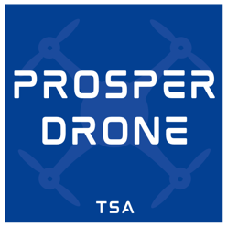 | Prosper Drone & TSA Booster Club Release Form

I grant Prosper Drone and TSA Booster Club, and its representatives, the right to take photographs of me. Furthermore, I authorize Prosper Drone and TSA Booster Club to use and publish the photographs in print and/or electronically. I release my rights to all photos which I may be photographed in.

I agree that Prosper Drone and TSA Booster Club may use photographs of me for any lawful purpose, including publicity, illustration, advertising, and web content.

Students Printed Name: __________________________________________

Student’s Signature: _____________________________________________ (Most be 18)

OR

Parent / Guardian Signature: ______________________________________

